Agency Name
Strategic Plan
2023 – 2025
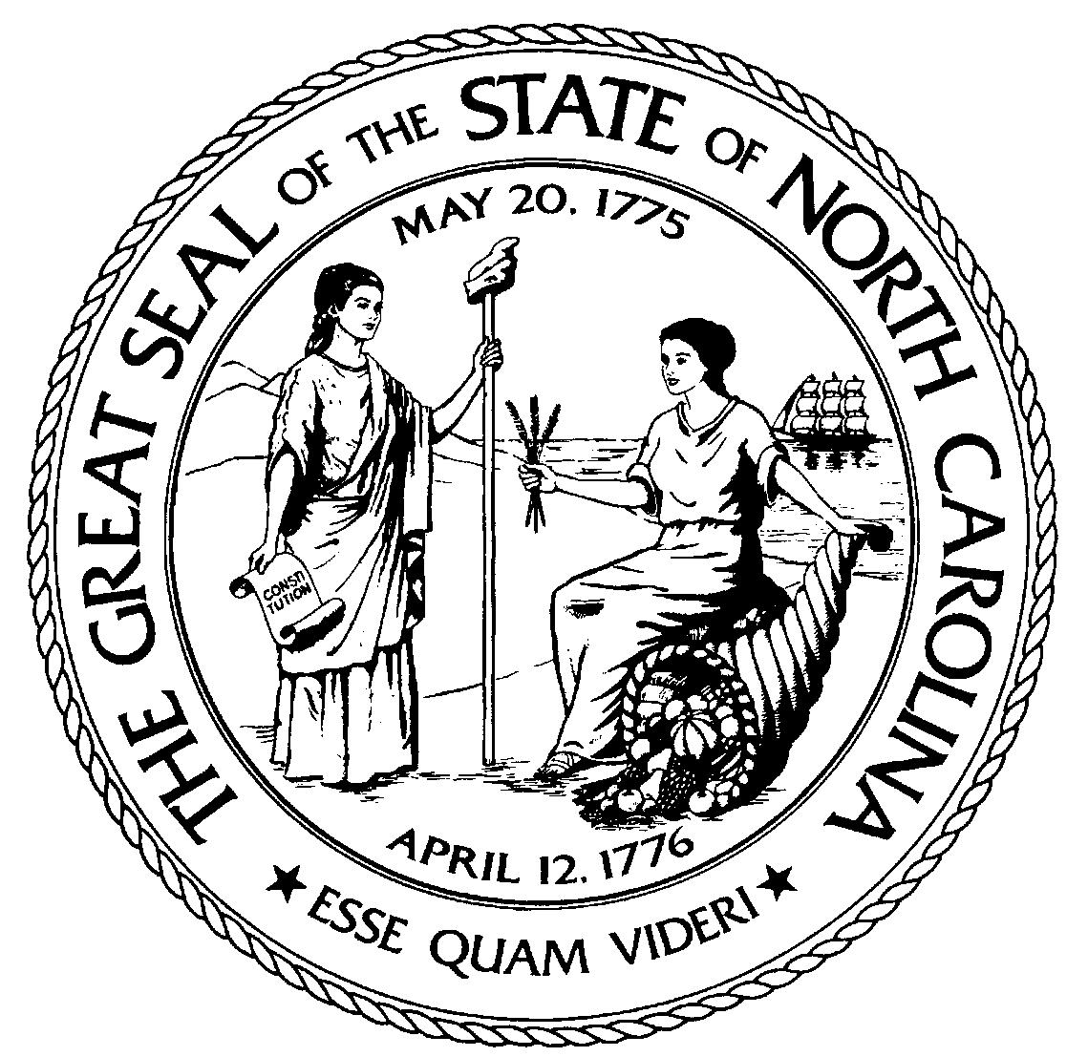

This page left blank intentionally

Contents

1. Strategic Plan Executive Summary 2
2. Mission, Vision, and Values 3
3. Goals, Objectives, and Performance Measures 4
4. Highlights, Collaborative Opportunities, and Priority Questions 5

Strategic Plan Executive Summary

(Insert a high-level summary of your agency’s strategic plan here. This should be a 1-2 page section that touches on the scope of your agency’s work, the process for creating your strategic plan, and a brief summary of what your agency aims to accomplish over the next biennium).

Mission, Vision, and Values

Agency Mission Statement
(Insert mission statement).

Agency Vision Statement
(Insert vision statement).

Agency Values
(Insert values).

Goals, Objectives, and Performance Measures
Note – The table below is a suggested format for organizing your agency’s goals, objectives, and performance measures. If your agency has a preferred format, you are welcome to use it as long as the same basic elements are captured. While this table provides a format matching one objective to one performance measure, there may be cases where multiple objectives are linked to one measure and vice versa. Agencies should feel free to manipulate this table to best fit the needs of their plans.
Goal 1 – (Insert a statement of intent that clearly supports the agency’s mission as well as aligns with its vision and values).
Objective 1.1 – (Insert a measurable, time-based statement of intent that directly links to the corresponding goal).  If the associated Performance Measure links to additional Objectives, insert more rows into the template and number accordingly. | Performance Measure or Milestone 1.1 – (Insert a measure or milestone that captures the progress in achieving Objective 1.1. It should clearly define a method and a unit of measurement or desired event).  If the associated Objective links to additional Performance Measures, insert more rows into the template and number accordingly.
Objective 1.2 – (Insert a measurable, time-based statement of intent that directly links to the corresponding goal).  If the associated Performance Measure links to additional Objectives, insert more rows into the template and number accordingly. | Performance Measure or Milestone 1.2 – (Insert a measure or milestone that captures the progress in achieving Objective 1.2. It should clearly define a method and a unit of measurement or desired event).  If the associated Objective links to additional Performance Measures, insert more rows into the template and number accordingly.
Objective 1.3 – (Insert a measurable, time-based statement of intent that directly links to the corresponding goal).  If the associated Performance Measure links to additional Objectives, insert more rows into the template and number accordingly. | Performance Measure or Milestone 1.3 – (Insert a measure or milestone that captures the progress in achieving Objective 1.3. It should clearly define a method and a unit of measurement or desired event).  If the associated Objective links to additional Performance Measures, insert more rows into the template and number accordingly.

Highlights, Collaborative Opportunities, and Priority Questions
Agency Highlights
(Insert success stories or operations that your agency wants to highlight. This section is an opportunity to demonstrate results or best practices that might be useful to share with other agencies. Include strategies or performance related initiatives that have yielded results).

Collaborative Opportunities
(Insert any identified opportunities for statewide or inter-agency collaborative initiatives that would yield significant efficiencies or improve effectiveness in State programs).

Priority Questions
(Insert 3-5 priority questions to answer. Consider adding a brief explanation for why the answers would be important and what decisions or actions they will inform).

